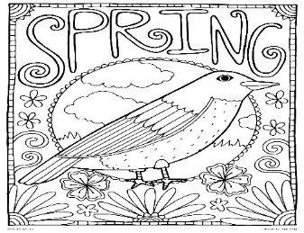
This Photo by Unknown Author is licensed under CC BY-SA-NC
BASW/MSW Practicum Schedule for Fall 2024/Spring 2025
August 2024
- 8/26/24 (Monday) – Fall Term Classes Begin

September 2024
- 9/2/24 – Labor Day (University Closed)
- 9/6/24 (Friday) – Add/Drop period ends

October 2024
- 10/4/24 – Practicum Learning Plan Due for BASW and MSW Specialized Practice
- 10/14/24 – Fall Break for Students
- Mar 1st - Fellowship applications due
- Mar 21st 9-noon – SIFI: Let’s talk about Cultural Humility and Competence
Register for: SIFI Let's Talk about Cultural Humility/Competence
- Spring Break – March 10th – 17th
- Mar 19th NASW Legislative Advocacy Day (Harrisburg)

November 2024
- 11/15/24 – Practicum Learning Plan – MSW Generalists
- 11/25/24 – 12/1/24 – Thanksgiving Break

Continued on the next page.
December 2024
- 12/2/24 – BASW, MSW Generalist and MSW Specialization Practicum Evaluations Due
- 12/17/24 – Fall term ends
- 12/19/24 – Fall Grades must be approved by 11:59 pm. Residence Hall closes

January 2025
- 1/8/25 – Spring Term Classes Begin
- 1/21/25 – Spring Term Add/Drop Ends

February 2025
- BASW Students 2nd Practicum Learning Plan due
- 2/14/25 – Summer Term enrollment begins (Veteran Students)
- 2/17/25 – Summer Term enrollment begins (Non- Veteran Students)

March 2025
- Starting 3/1/24 Fellowship applications due (check Fellowship for actual date0
- 3/2/24 – 3/9/24 – Spring Break
- 3/11/24 – Deadline to submit monitored withdrawal forms
- 3/21/24 – Fall term enrollment begins (Veteran Students)
- 3/24/24 – Fall term enrollment (Non-Veteran Students)

April 2025
- 4/7/25 – BASW, MSW Generalists and MSW Specialist Practicum Evaluations Due
- 4/30/25 – Spring Term Ends

May 2025
- 5/4/25 – Undergraduate and Graduate Graduation

IMPORTANT LINKS:

Link to the ACADEMIC CALENDAR - 2024/2025 Academic Calendar

Academic Resources Link:
https://www.socialwork.pitt.edu/student-resources/incomingnew-students

